Postmortem of some causative agents
1- Bacterial diseases:
Anthrax: Is a zoonotic disease caused by the spore forming. It most common wild and domestic herbivores but can also be seen in humans exposed to tissues from infected animals, contaminated animal products or directly to spores under certain conditions. Depending on the route of infections, host factors, and potentially strain - specific factor, anthrax can have several different clinical presentations. In herbivores anthrax commonly presents as an acute septicemia with high fatality rate, often accompanied by hemorrhagic lymphadenitis in dogs, horses, pigs, and human, it is usually less acute B. anthracis spores can remain in infective in soil for many years.
Lesion
Grossly:
1- Rigor mortis infrequently absent or incomplete.
2-Dark blood may ooze from the mouth, nostrils, and anus with marked bloating and rapid body decomposition.
3-The carcass is inadvertently opened, septicemic lesions are seen. The blood is dark and thickened and fails to clot readily. Hemorrhages of various size.
4-Hemorrhages frequently occur along the GI tract mucosa, and ulcers particularly over peyer’s patches, may be present.
5-An enlarged, Dark red or black, soft, semi fluid spleen is common spleen.
6-The liver, Kidney, and lymph nodes usually are congested and enlarged.
7-Meningitis may be found if the skull is opened.

B – Tuberculosis:
Bovine tuberculosis (bovine TB) is a contagious chronic disease of cattle caused by Mycobacterium bovisand associated with progressive emaciation and tubercle (granuloma) formation involving most usually the respiratory system but also other organs. As well as being of great economic importance to the livestock industry, because humans can be infected, it is also an important public health issue.
Postmortem findings:
1-Tuberculous granuloma in the lymph nodes of the head, lungs, intestine and carcass. These have usually a well defined capsule enclosing a caseous mass with a calcified centre. They are usually yellow in colour in cattle, white in buffaloes and grayish white in other animals.
2-Active lesions may have a reddened periphery and caseous mass in the centre of a lymph node.
3-Inactive lesions may be calcified and encapsulated.
4-Nodules on the pleura and peritoneum.
5-Lesions in the lungs, liver, spleen, kidney.
6-Bronchopneumonia
7-Firmer and enlarged udder, particularly rear quarters
8-Lesions in the meninges, bone marrow and joints

2- Parasitic infection:
- Echinococcus
Post Mortem Lesions: There are no lesions in the definitive hosts. Most species have five or fewer segments, although some individual specimens may have up to seven. In the intermediate hosts, the cysts are grossly apparent in tissues at necropsy.
E. granulosus s. metacestodes are usually individual fluid-filled cysts, surrounded by a fibrous wall. Most cysts are 1-7 cm in diameter, but some can become much bigger.
Some cysts may be calcified, necrotic or infected. Although most cysts occur in the liver, some may be found only in the lungs or, less often, in other internal organs including the bones. Organs to be examined in large animals should be palpated or incised if cysts are not seen.
E. multilocularis metacestodes occur initially in the liver, but they can metastasize to other organs, particularly the lungs and CNS. These multilocular cysts have a semisolid matrix and resemble malignant tumors. They may
be firm and lobulated or contain viscous fluid, and can contain many scattered transparent cysts of a few millimeters to centimeters in diameter. The center of the lesion may be necrotic. In pigs, E. multilocularis lesions may be sharply demarcated, dense white foci of approximately 1-20 mm in diameter.

3- Viral infections:
- Ebola virus
Ebola is a rare disease caused by infection with a virus of the family Filoviridae, genus Ebolavirus. There are five identified Ebola virus species. Four of the five have caused disease in humans: Ebola virus (Zaire ebolavirus); Sudan virus (Sudan ebolavirus); Taï Forest virus (Taï Forest ebolavirus, formerly Côte d’Ivoire ebolavirus); and Bundibugyo virus (Bundibugyo ebolavirus). The fifth, Reston virus (Reston ebolavirus), has caused disease in nonhuman primates but not in humans.
PATHOGENESIS
Because of the difficulty of performing clinical studies under outbreak conditions, almost all data on the pathogenesis of Ebola virus disease have been obtained from laboratory experiments employing mice, guinea pigs, and nonhuman primates. Pathogenesis includes:
- -Cell entry and tissue damage
- -Gastrointestinal dysfunction
- -Systemic inflammatory response
- - Coagulation defects
- Impairment of adaptive immunity-
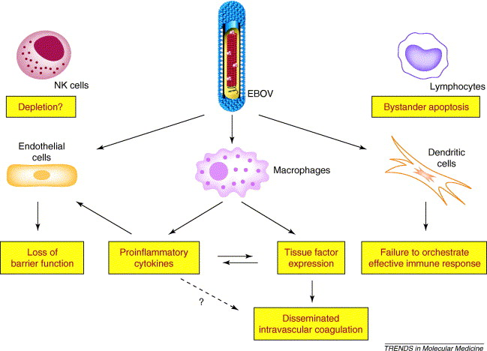

Diagram appear pathogenesis of Ebola virus

